Car price prediction using
Neural Networks

By

Lina AL-Hayani
24000024

Ahmad AL-Mustafa
24000022

Ali AL-Hasan
24000014

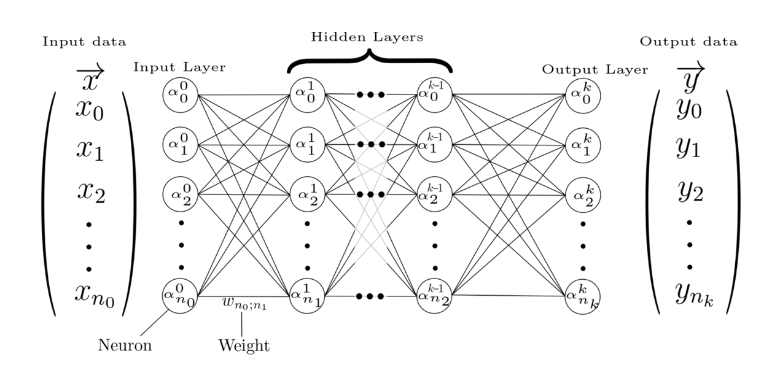
Table of Contents

1-st Section: EDA

2-nd Section:
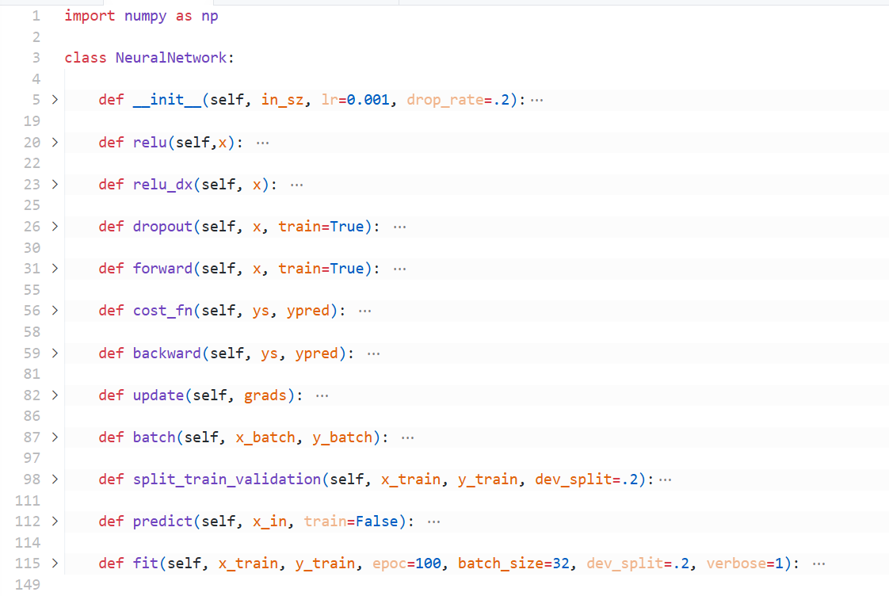
Building the Neural network:
Figure 2.1: the back-bone or the Neural Network implementation.
2.1 Class Initialization:
def __init__(self, in_sz, lr=0.001, drop_rate=.2):
self.lr = lr
self.drop_rate = drop_rate
self.ws = []
self.bs = []
self.Zs = {}
self.dropout_msks = {}
for i in range(len(in_sz) - 1):
kaim_he_factor = np.sqrt(2/in_sz[i])
w = np.random.randn(in_sz[i],in_sz[i+1]) * kaim_he_factor
b = np.zeros((1, in_sz[i+1]))
self.ws.append(w)
self.bs.append(b)

Establishes the network architecture with properly scaled initial parameters to prevent vanishing/exploding gradients.
Parameters:
- in_sz: A list specifying the number of neurons in each layer [input, hidden1, hidden2, ..., output].
- lr: Learning rate.
- drop_rate: Dropout probability for regularization.
Initialization Process:
- Sets the learning rate and dropout rate as instance variables and initializes empty lists for weights (ws) and biases (bs) Creates dictionaries to store intermediate values (Zs) and dropout masks (dropout_msks).
- For each pair of hidden layers we used the kaiming/He initialization to initializes weights with random values from a normal distribution scaled by the He factor to prevent vanishing/exploding gradients:
$$He=\sqrt{\frac{2}{n_{in}}}$$
Where $n_{in}$ The number of inputs to the layer.
- Initialize biases with zeros.
2.2 Activation Functions:
def relu(self,x):
return np.maximum(0,x)

def relu_dx(self, x):
return (x > 0).astype(float)

Implements the Rectified Linear Unit activation (Relu) function and it’s derivative.
Parameters:
- x: the weighted sum of inputs plus the bias for a specific neuron before it is activated.
Mechanism:
- relu: returns the input value for positive values and 0 for negative values.
- relu_dx: returns 1 for positive values and 0 for negative values.

2.3 Dropout Regularization:
def dropout(self, x, train=True):
msk = np.random.rand(*x.shape) > self.drop_rate
msk_scaled = x * msk / (1 - self.drop_rate)
return msk_scaled if train else x
This function is used to prevents overfitting by randomly deactivating neurons during training.
Parameters:
- x: the weighted sum of inputs plus the bias for a specific neuron before it is activated.
- train: to specify that this function is only applied during training process.
Mechanism:
- it creates a binary mask where each neuron has drop_rate probability of being set to $0$, then it scales remaining activations by $\frac{1}{1-DropRate}$ to maintain the expected value.

2.4 Forward Pass Calculation:
def forward(self, x, train=True):
self.Zs = {}
curr_in = x
self.Zs['a0'] = x
for i in range(len(self.ws) - 1):
z = np.dot(curr_in, self.ws[i]) + self.bs[i]
self.Zs[f'z{i+1}'] = z
a = self.relu(z)
self.Zs[f'a{i+1}'] = a
if train and i < len(self.ws) - 2:
a = self.dropout(a, train)
self.Zs[f'droput_msk{i+1}'] = self.dropout_msks.get(f'dropout_msk{i+1}', None)
curr_in = a
# Move this outside the for loop - THIS IS THE FIX
last_idx = len(self.ws) - 1
z_out = np.dot(curr_in, self.ws[last_idx]) + self.bs[last_idx]
self.Zs[f'z{len(self.ws)-1}'] = z_out
return z_out

This function performs the forward pass through the network to compute predictions.

Parameters:
- x: the weighted sum of inputs plus the bias for a specific neuron before it is activated.
- train: to specify if we are during training or not.
Mechanism:
- stores input as activation layer 0: $a^{\left[0\right]}$.
- for each hidden layer (except the output layer):
  - computes: $z=w*a+b$.
  - applies Relu activation: $a=relu(z)$.
  - stores those values after activation and applies dropout (if training).
- for the output layer it computes the value $z$ without activation.

2.5 Cost Functions:
def cost_fn(self, ys, ypred):
return np.mean((ypred - ys)**2)
This function implements Mean Squared Error (MSE) as the loss function.
Parameters:
- ys: the true value we are trying to predict.
- ypred: the predicted value by the network.
Mechanism:
- Computes the average squared difference between predictions and actual values.

2.6 Backward Propagation:
def backward(self, ys, ypred):
m = ys.shape[0]
grads_w = []
grads_b = []

dz = ypred - ys
dz = dz * (2/m)

for i in range(len(self.ws)-1, -1, -1):
a_prev = self.Zs[f'a{i}'] if i > 0 else self.Zs['a0']
dw = np.dot(a_prev.T, dz)
db = np.sum(dz, axis=0, keepdims=True)

grads_w.insert(0, dw)
grads_b.insert(0,db)

if i > 0:
da = np.dot(dz, self.ws[i].T)
z_prev = self.Zs[f'z{i}']
dz = da * self.relu_dx(z_prev)

return grads_w, grads_b
This function implements the backpropagation algorithm with the chain rule, propagating error gradients from output to input (Computes gradients of the loss with respect to all parameters using the chain rule).
Parameters:
- ys: the true value we are trying to predict.
- ypred: the predicted value by the network.
Mechanism:
- output layer gradient: $dz=\frac{1}{m}(ypred-ys)$ the derivative of MSE.
- Iterate backwards through layers:
  - Compute weigh gradients: $dw=a_{prev}*dz$.
  - Compute bias gradients: $db=∑dz$.
  - Propagate gradients backward: $da=dz*w$.
  - Compute activation derivative: $dz=da*relu(z_{prev})$.
- Returns lists of gradients for both ws and bs.

2.7 Parameters Update:
def update(self, grads):
for i in range(len(self.ws)):
self.ws[i] -= self.lr * grads[0][i]
self.bs[i] -= self.lr * grads[1][i]
This function gradient descent update on all parameters with the learning rate lr.
Parameters:
- grads: a list of gradients for both ws and bs.
Mechanism:
- for each layer:
  - $w=w-lr*dw$.
  - $b=b-lr*db$.

2.8 Mini-Batch Processing:
def batch(self, x_batch, y_batch):
ypred = self.forward(x_batch, train=True)
loss = self.cost_fn(y_batch, ypred)
grads = list(self.backward(y_batch, ypred))
self.update(grads)
return loss
This function performs one forward & backward pass on a mini-batch.
Parameters:
- x_batch: the input data.
- x_batch: the target value.
Mechanism:
- it and computes the loss and executes backward propagation and update parameter using the gradients.

2.9 Data Splitting:
def split_train_validation(self, x_train, y_train, dev_split=.2):
n = x_train.shape[0]
val_sz = int(n*dev_split)
indices = np.random.permutation(n)
train = indices[val_sz:]
val = indices[:val_sz]

x_train_split = x_train[train]
y_train_split = y_train[train]
x_val = x_train[val]
y_val = y_train[val]

return x_train_split, y_train_split, x_val, y_val
This function performs random stratified splitting of training data using sklearn.
Parameters:
- x_train: the input data.
- y_train: the target value.
- dev_sz: the size of the validation set.

2.10 Prediction:
def predict(self, x_in, train=False):
return self.forward(x_in, False)
This function performs forward propagation for inference & and set the dropout to False (this is not training).
Parameters:
- x_in: the input data.

2.11 Training Loop:
def fit(self, x_train, y_train, epoc=100, batch_size=32, dev_split=.2, verbose=1):
x_train_split, y_train_split, x_val, y_val = self.split_train_validation(x_train, y_train, dev_split=dev_split)
n = x_train_split.shape[0]
records = {
'loss': [],
'val_loss': [],
'mae': [],
'val_mae': []
}

for epoch in range(epoc):
# Shuffle data each epoch
indices = np.random.permutation(n)
x_shuffled = x_train_split[indices]
y_shuffled = y_train_split[indices]

epoch_losses = []

for i in range(0, n, batch_size):
x_batch = x_shuffled[i:i+batch_size]
y_batch = y_shuffled[i:i+batch_size]
loss = self.batch(x_batch, y_batch)
epoch_losses.append(loss)

# Record metrics every epoch
train_pred = self.predict(x_train_split)
train_loss = self.cost_fn(train_pred, y_train_split)
train_mae = np.mean(np.abs(train_pred - y_train_split))

val_pred = self.predict(x_val)
val_loss = self.cost_fn(val_pred, y_val)
val_mae = np.mean(np.abs(val_pred - y_val))

records['loss'].append(train_loss)
records['mae'].append(train_mae)
records['val_loss'].append(val_loss)
records['val_mae'].append(val_mae)

if verbose and epoch % 10 == 0:
print(f"Epoch {epoch}: Train Loss={train_loss:.4f}, Val Loss={val_loss:.4f}")

return records
This function performs the complete training process.
Parameters:
- x_train: the input data.
- y_train: the target value.
- epoc: the number of training loop.
- batch_size: the number of training samples processed by the network before it update its parameters.
- dev_split: the validation split size.
- verbose: control the amount of information the model prints during training.
Mechanism:
- Data Preparation: Splits data into training/validation sets.
- Mini-Batch processing:
  - Shuffles data each epoch
  - Process data in batches and updates parameters after each batch.
- Loss Tracking:
  - Records training & validation loss, MAE.

Neural Network Architecture:
- Relu activation for hidden layers.
- No activation for the output layer.
- kaiming/He initialization for stable gradients.
- Dropout regularization to prevent overfitting.
- Mini-batch gradient decent for efficiency.

